1.Gateway Installation Process
1. install Putty application.
2.Do the setup first u use public IP then in Auth section in crendatial section put the downloaded file qamumbai.
3.after setup in command prompt use commands
1.login as ubuntu
2.for root ip use= sudo -i
3.creat new config file using command = touch tanu.sh
4.then use = nano tanu.sh
5.then in console download section install u are gatway agent which newly created just install linux file and copy the all crendatial code.
6.paste into putty command prompt use c^ O and c^ X .
7.install the command= sudo bash tanu.sh
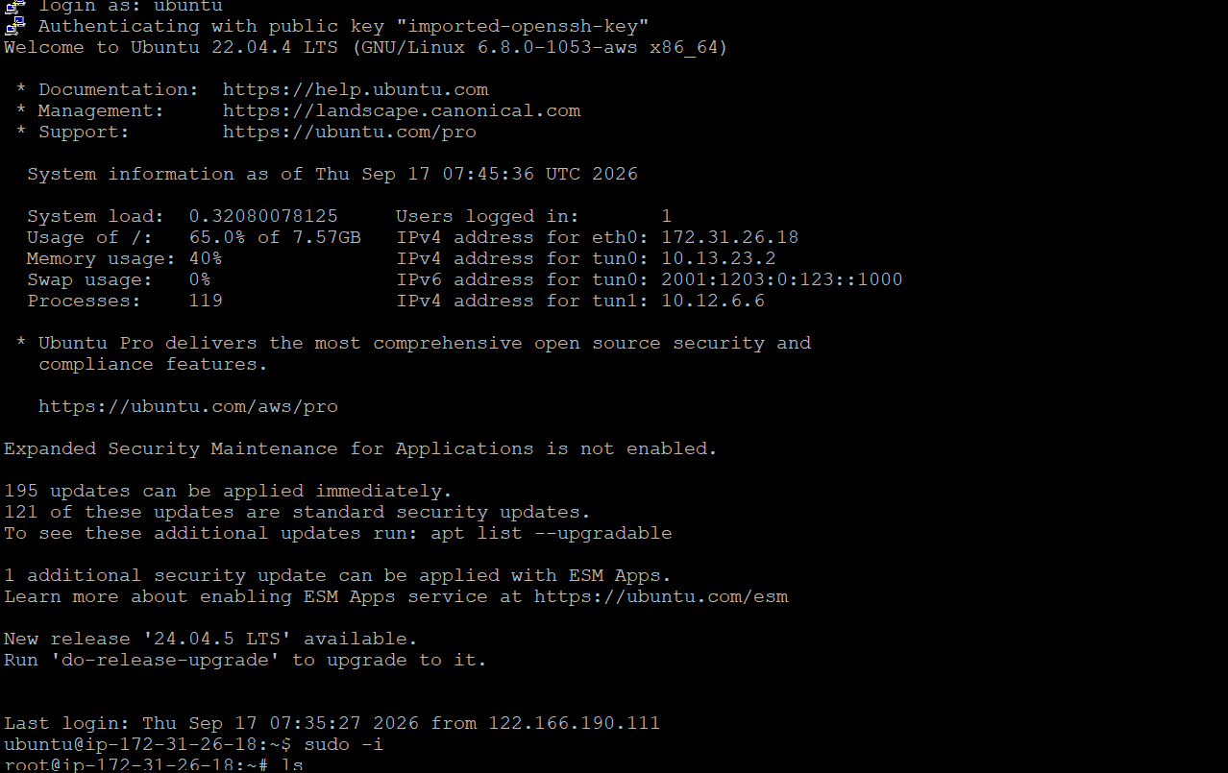
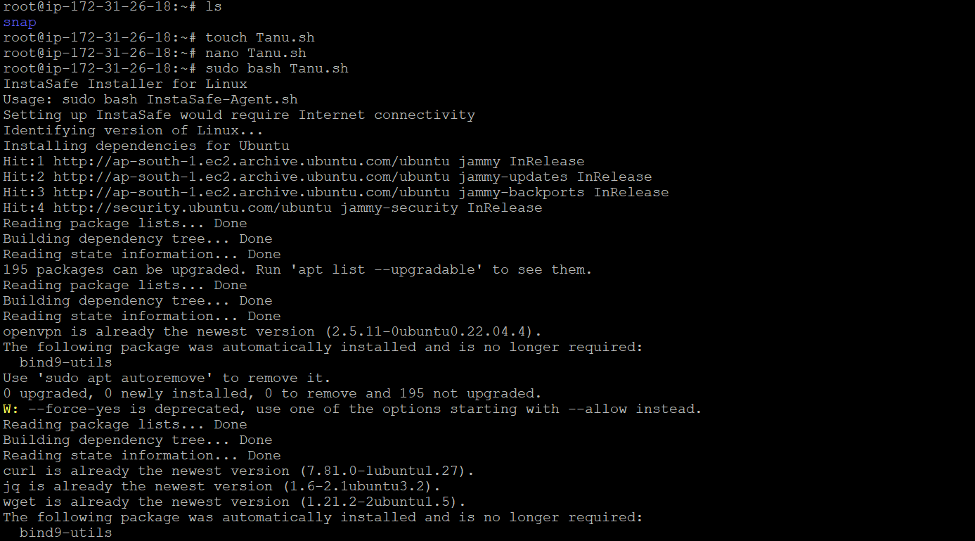

Path of config file
1)check config file
cd /etc/instasafe
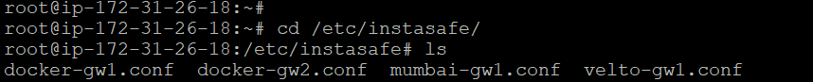
2)check log file
cd /var/log/
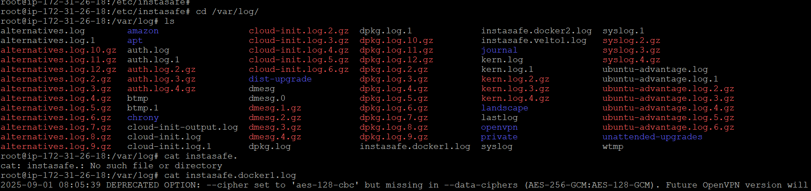
2.Uninstallation procees commands
1.use command= sudo rm -rf tanu.sh
2. sudo service instasafe stop
3.sudo service instasafe status
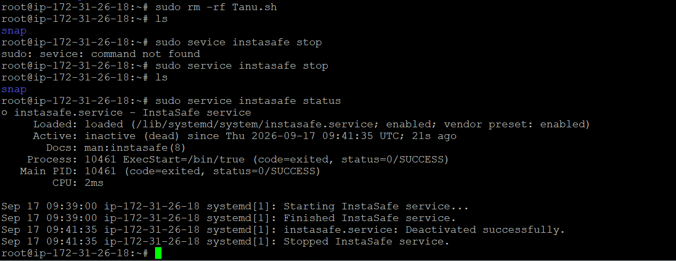
Rm -rf /etc/instasafe
Rm -rf /var/log/instasafde*
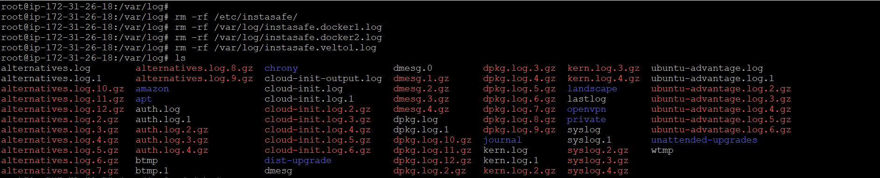

What is an InstaSafe Gateway?
A Gateway is a piece of software installed in a company's data center or cloud network. It acts as a security guard—checking whether a user is authorized before letting them access company applications or servers.
Types of Gateways
InstaSafe offers different types depending on what users need to access:

- TCP Gateway: Used for web applications or user syncing. Supports up to 1,500 concurrent users.
- Network Gateway: Used to access private servers or cloud apps securely via a VPN profile. Supports up to 1,000 concurrent users.
- RDP Gateway: Used for connecting remotely to external computers or servers using RDP or SSH.
- Agentless Gateway: Allows users to access applications directly from a web browser without installing any software on their device. Supports up to 1,500 concurrent users.
- Unified Gateway: Combines all the functions above into a single gateway, helping companies save hardware costs and manage settings easily in one place.
Basic System Requirements
To run a gateway, the Virtual Machine (VM) needs at least:
- Operating System: Ubuntu 22.04.2 LTS (64-bit)
- CPU: 4 Cores
- RAM: 8 GB
- Storage: 30 GB free space

